Prairie Point Quilt Gallery
Asset # 251

Gammill Long Arm Quilting, Model G with Statler Computer Automation and creative Studio.

Serial Number: 21505116300 M

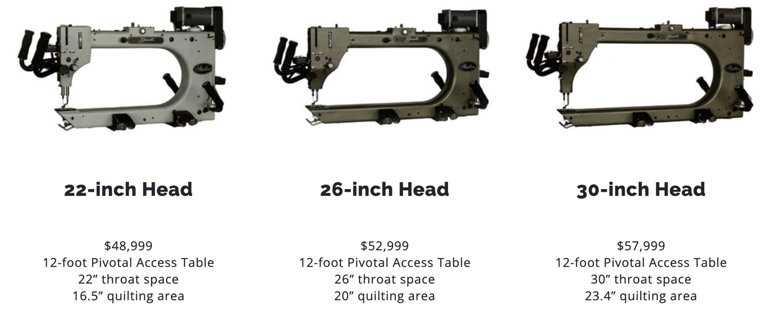

Nominal Value
$45,000 – $50,000

Prairie Point Quilt Gallery
Asset #252

Baby Lock Embroidery Porfessional Model BMP8

Serial Number: J713113868

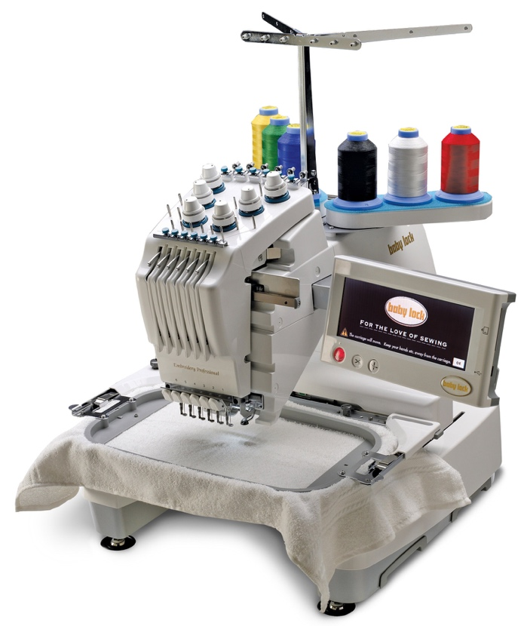

Nominal Value
$10,000

Prairie Point Quilt Gallery
Asset #253

Baby Lock Imagine Wave Serger

Serial Number: J3101205

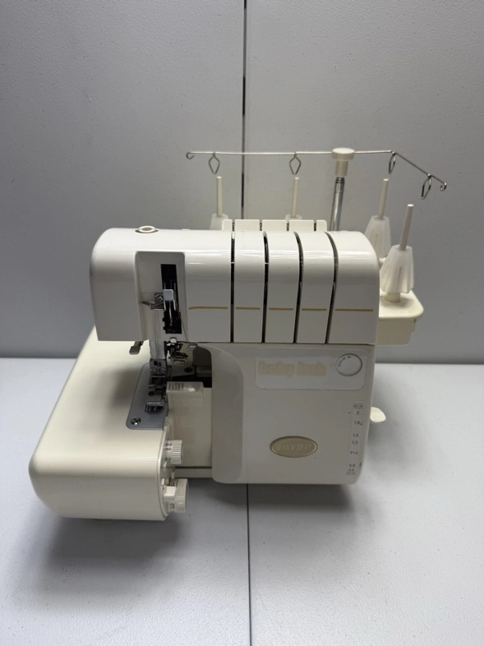

Nominal Value
$750

Prairie Point Quilt Gallery
Asset #254

Bernina Artista 730 Sewing Machine

Serial Number:

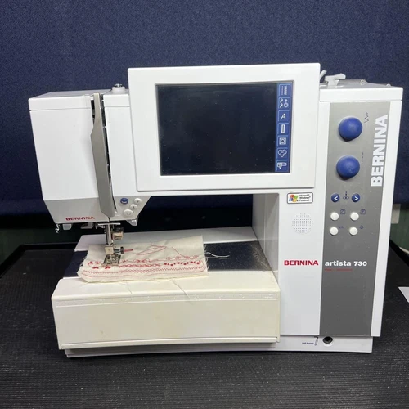

Nominal Value
$1,500

Asset # | Value | Replacement Value (new)
251 | $45,000 | $58,000
252 | $10,000 | $15,000
253 | $750 | $1,500
254 | $1,500 | $3,000
255
Total | $57,250 | $77,500

Supplies & PC computers $2,000

The Liquidation Value of all assets is approximately $59,000.

I would prefer to sell the business entity for $75,000 and finance the purvcase for 5 years @ 6% interests

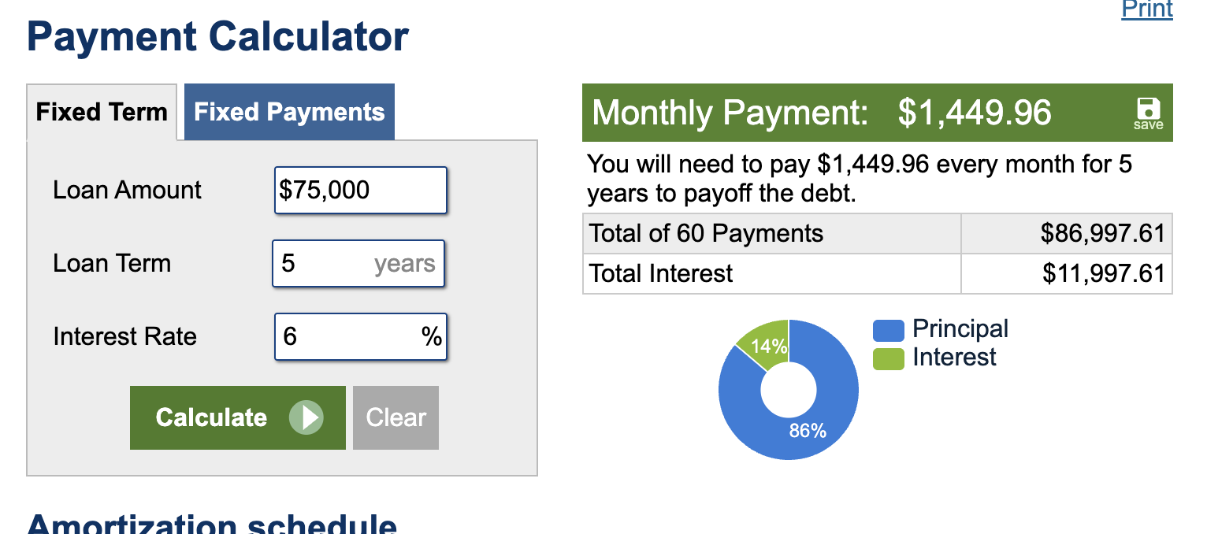

This annuity matches my home Mortgage which makes this option very appealing. To make this option more appealing I would be willing to allow the business to operate out of my home for up to 6 Months with an opt-out at the end of 6 months. My assumption is that the business will be cash flow positive at the end of six months.

Prairie Point Quilting Studio is the continuation of Prairie Point Quilting operated by Peggy Tanler. Due to her tragic accident, I Peggy’s husband,have decided to continue to operate her business. I cannot match Peggy’s passion for design but I have enrolled in classes to learn to operate our Gammill/Statler long Arm Quilting Machine and Baby Lock Embroidery Machine.
I plan to operate an gallery, a resource for textile artist. We have hundreds of quilt patterns. That can be arranged to en=hance the artist’s quilt. I want tp worl with the artist to complete the quilt. I am planning to remodel our textile arts studio. I am open to ideas.

